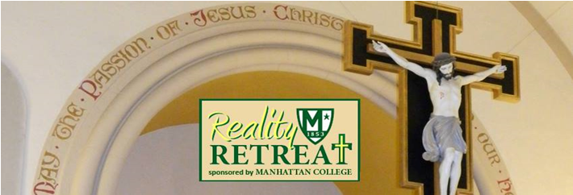
Greetings from your Retreat Team. The 2017 Manhattan College Businessmen’s Retreat reservation form is below. This year’s theme is:
Romans 12:2 “Do not conform, but be transformed by discerning the will of God”
Please RSVP now to confirm that you’ll be joining your brothers for the September retreat. Simply fill in, tear off, and mail the registration form below. If your circumstances allow, we ask that you enclose a deposit to reserve your spot.
Based on your feedback, another option this year is to pay by credit card; just call the retreat house at (718) 739-1229. In any case, please let us know that you’re planning to attend. You’ll be glad that you did!
X-------------------------------------------------------------------------------------------------------------------------X
Please reserve a spot for me at the Manhattan College Businessmen’s Reality Retreat 2016
September 15, 16 & 17th.
Enclosed is my $75.00 deposit, or if paying by credit card, call (718) 739-1229.
Make check payable to: BMRH
Mail form & check to: Bishop Molloy Passionist Retreat House
86-45 Edgerton Boulevard
Jamaica Estates, NY 11432
PLEASE PRINT CLEARLY
Last Name: ________________________________First Name: ___________________________
Address:_______________________________________________________________________
City: _______________________________State: _______________ Zip Code: _______________
Phone (Day): ________________________________Phone (Eve): _________________________
E-Mail: ________________________________________________________________________
The suggested weekend donation is $210.00. If you cannot afford it, give what you can afford. Being a part of this weekend is more important than any fiscal considerations. RSVP as soon as you can.
This is something to feel good about!

